**Virtual Key for Repositories**

**Project Description :** As a Full Stack Developer, complete the features of the application by planning the development in terms of sprints and then push the source code to the GitHub repository. As this is a prototyped application, the user interaction will be via a command line.

This document contains :

* **Sprint planning and Task completion**
* **Core concepts used in project**
* **Flow of the Application**
* **Working of Project**
* **Conclusions**

## Sprints planning and Task completion

The project is planned to be completed in 2 sprint. Tasks assumed to be completed in the sprint are:

1. **First sprint (4 days)**

* Creating the flow of the application
* Initializing git repository to track changes as development progresses.
* Writing the Java code to display welcome screen .
* Writing the java code to create main menu for select options.

1. **Second sprint (4 days)**

* Writing the java code to create sub menu for file operations.
* Testing the Java program with different kinds of User input
* Pushing code to GitHub.
* Creating this specification document highlighting application capabilities, appearance, and user interactions.

## Core concepts used in project

Collections framework, File Handling, Sorting Techniques, Flow Control, Searching, Exception Handling

## Flow of the Application

1. Working of Project
2. Creating the project in Eclipse
3. Writing a program in Java for the entry point of the application(**Main.java**)
4. Writing a program to display Menu options available for the user (**ScreenDisplay.java**)
5. Writing a program to handle Menu options selected by user (**ControlOperations.java**)
6. Writing a program to perform the file operations as specified by user (**FileOperations.java**)
7. Pushing the code to GitHub repository

## **Step 1:** Writing a program in Java for the entry point of the application (**Main.java**)

**package** locked.com;

**public** **class** Main {

**public** **static** **void** main(String[] args) {

// Create "locker" folder if not present in current folder structure

FileOperations.*createFolder*();

ScreenDisplay.*welcomeScreen*();

ControlOperations.*welcometoApp*();

}

}

## **Step 2:** Writing a program in Java to display Menu options available for the user (**ScreenDisplay.java**)

**Step 3.1:** Writing method to display Welcome Screen

**package** locked.com;

**public** **class** ScreenDisplay {

**public** **static** **void** welcomeScreen() {

String welcome = "** Welcome to Lockers Pvt. Ltd \n" + "** This application is developed by Rashmi Rathi \n"

+ "*****************************************************\n";

String info = "--------Company Lockers Pvt. Ltd. hired me as a Full Stack Developer-------\n"

+ "The goal of the company is to deliver a high-end quality product as early as possible. \n";

System.***out***.println(welcome);

System.***out***.println(info);

}

**public** **static** **void** displayMenu() {

String displaymenu = "\n\n### Select any number from below and press Enter ###\n\n"

+ "1) Retrieve all files in ascending order\n"

+ "2) Details of the user interface menu for File operations\n"

+ "3) Close the application\n";

System.***out***.println(displaymenu);

}

**public** **static** **void** displayFileMenu() {

String operations = "\n\n### Select any option number from below and press Enter ###\n\n"

+ "1) Add a file to the existing directory list\n"

+ "2) Delete a user specified file from the existing directory list\n"

+ "3) Search a user specified file from the main directory\n" + "4) Option to navigate back to the main context\n"

+ "5) close the application\n";

System.***out***.println(operations);

}

}

* **Output**

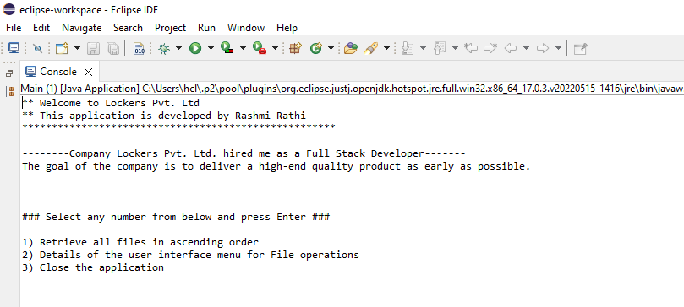

## 

## **Step 4:** Writing a program in Java to handle Menu options selected by user (**ControlOperations.java**)

**package** locked.com;

**import** java.util.Scanner;

**public** **class** ControlOperations {

**public** **static** **void** welcometoApp() {

**boolean** result = **true**;

Scanner sc = **new** Scanner(System.***in***);

**do** {

**try** {

ScreenDisplay.*displayMenu*();

**int** input = sc.nextInt();

**switch** (input) {

**case** 1:

FileOperations.*displayFiles*("locker");

**break**;

**case** 2:

ControlOperations.*fileMenu*();

**break**;

**case** 3:

System.***out***.println("Program exited successfully.");

result = **false**;

sc.close();

System.*exit*(0);

**break**;

**default**:

System.***out***.println("Please select a valid option from above.");

}

} **catch** (Exception e) {

System.***out***.println(e.getClass().getName());

*welcometoApp*();

}

} **while** (result == **true**);

}

**public** **static** **void** fileMenu() {

**boolean** result = **true**;

Scanner sc = **new** Scanner(System.***in***);

**do** {

**try** {

ScreenDisplay.*displayFileMenu*();

FileOperations.*createFolder*();

**int** input = sc.nextInt();

**switch** (input) {

**case** 1:

// File Add

System.***out***.println("Enter the name of the file to be added to the \"locker\" folder");

String fileToAdd = sc.next();

FileOperations.*addFile*(fileToAdd, sc);

**break**;

**case** 2:

// File delete

System.***out***.println("Enter the name of the file to be deleted from \"locker\" folder");

String filename = sc.next();

FileOperations.*deleteFile*(filename, sc);

**break**;

**case** 3:

// File Search

System.***out***.println("Enter the name of the file to be searched from \"locker\" folder");

String fileName = sc.next();

FileOperations.*searchFile*(fileName, sc);

**break**;

**case** 4:

// Go to Previous menu

**return**;

**case** 5:

// Exit

System.***out***.println("Program exits successfully.");

result = **false**;

sc.close();

System.*exit*(0);

**default**:

System.***out***.println("Please select a valid option from above.");

}

} **catch** (Exception e) {

System.***out***.println(e.getClass().getName());

*fileMenu*();

}

} **while** (result == **true**);

}

* **Output**

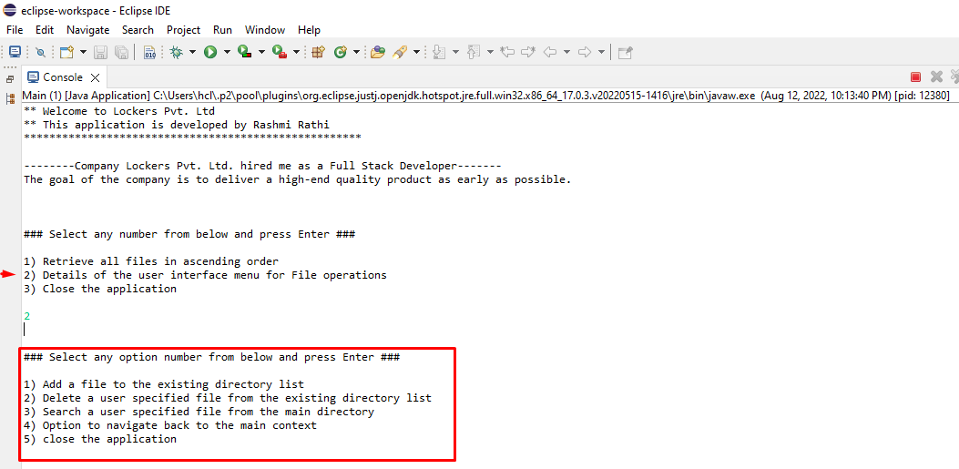

## **Step 5:** Writing a program in Java to perform the File operations as specified by user (**FileOperations.java**)

**package** locked.com;

**import** java.util.Scanner;

**public** **class** ControlOperations {

**public** **static** **void** welcometoApp() {

**boolean** result = **true**;

Scanner sc = **new** Scanner(System.***in***);

**do** {

**try** {

ScreenDisplay.*displayMenu*();

**int** input = sc.nextInt();

**switch** (input) {

**case** 1:

FileOperations.*displayFiles*("locker");

**break**;

**case** 2:

ControlOperations.*fileMenu*();

**break**;

**case** 3:

System.***out***.println("Program exited successfully.");

result = **false**;

sc.close();

System.*exit*(0);

**break**;

**default**:

System.***out***.println("Please select a valid option from above.");

}

} **catch** (Exception e) {

System.***out***.println(e.getClass().getName());

*welcometoApp*();

}

} **while** (result == **true**);

}

**public** **static** **void** fileMenu() {

**boolean** result = **true**;

Scanner sc = **new** Scanner(System.***in***);

**do** {

**try** {

ScreenDisplay.*displayFileMenu*();

FileOperations.*createFolder*();

**int** input = sc.nextInt();

**switch** (input) {

**case** 1:

// File Add

System.***out***.println("Enter the name of the file to be added to the \"locker\" folder");

String fileToAdd = sc.next();

FileOperations.*addFile*(fileToAdd, sc);

**break**;

**case** 2:

// File delete

System.***out***.println("Enter the name of the file to be deleted from \"locker\" folder");

String filename = sc.next();

FileOperations.*deleteFile*(filename, sc);

**break**;

**case** 3:

// File Search

System.***out***.println("Enter the name of the file to be searched from \"locker\" folder");

String fileName = sc.next();

FileOperations.*searchFile*(fileName, sc);

**break**;

**case** 4:

// Go to Previous menu

**return**;

**case** 5:

// Exit

System.***out***.println("Program exits successfully.");

result = **false**;

sc.close();

System.*exit*(0);

**default**:

System.***out***.println("Please select a valid option from above.");

}

} **catch** (Exception e) {

System.***out***.println(e.getClass().getName());

*fileMenu*();

}

} **while** (result == **true**);

}

* **Output**

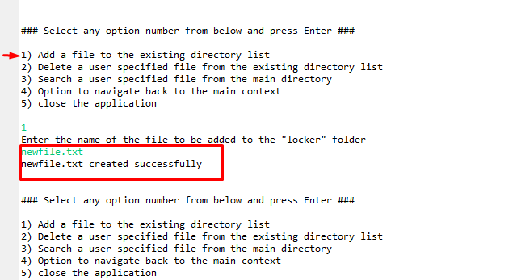

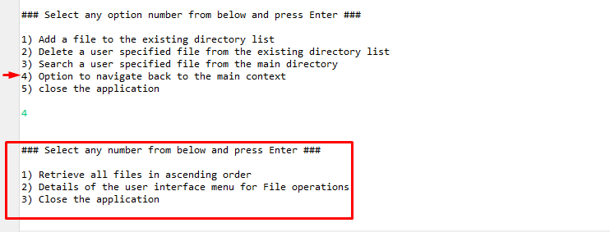

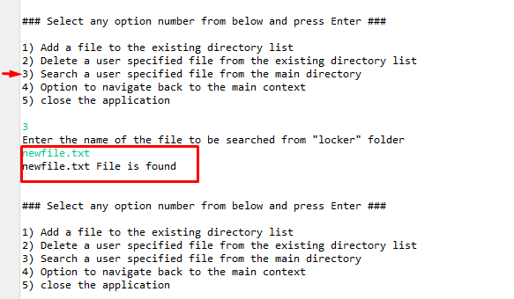

* **If user give invalid input**

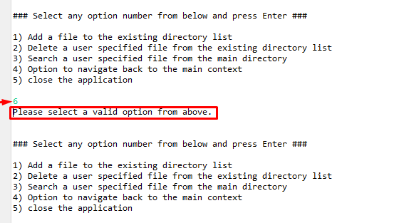

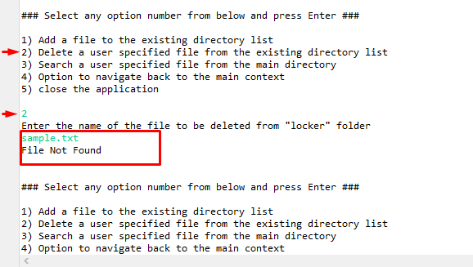

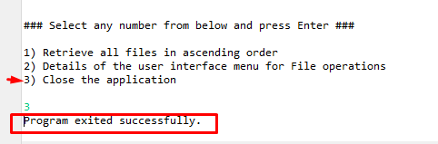

**Conclusion:**

* User can add a file in “locker” folder which is created very first when this application is run by  ignoring the case sensitivity
* User can delete a specified file from the existing directory list .This operation is case sensitive and return a message if FNF (File not found).
* Search a user specified file from the main directory(“locker”) . This operation is case sensitive.
* Option to navigate back to the main context
* Option to close the application